**FOLLOW TUTORIAL 3 to continue**

**Step 1**

**Create 2 empty GameObjects and put them in your aim position and your initial position.**

Start of by selecting your rifle in the hierarchy, then right clicking and adding empty GameObject. Next rename this InitialPosition and change the icon of the object to make clearer in the scene room.

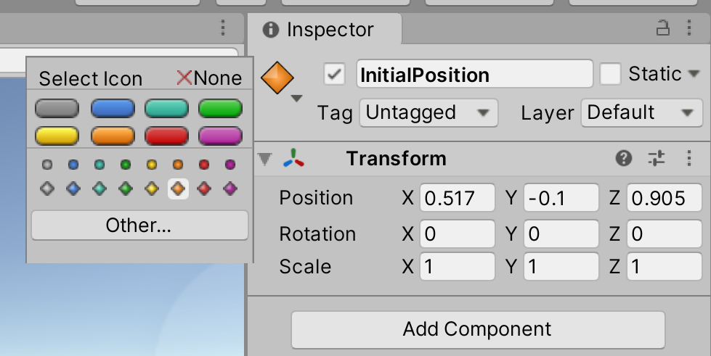

Then drag this into the main camera and duplicate it. Rename the other empty GameObject to AimPosition and move into the rifle, then again change the icon to something other then the same one used for InitialPosition.

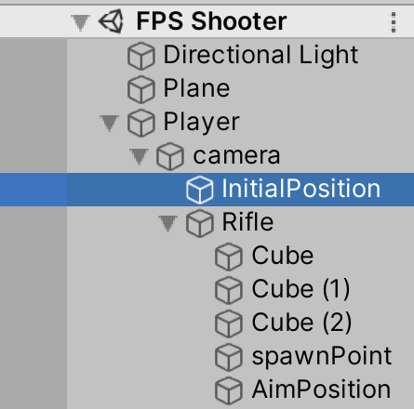

Then next move over the Aimposition over to the left of where the gun Is facing inline with the camera, as well as stilling being inline with the InitialPosition.

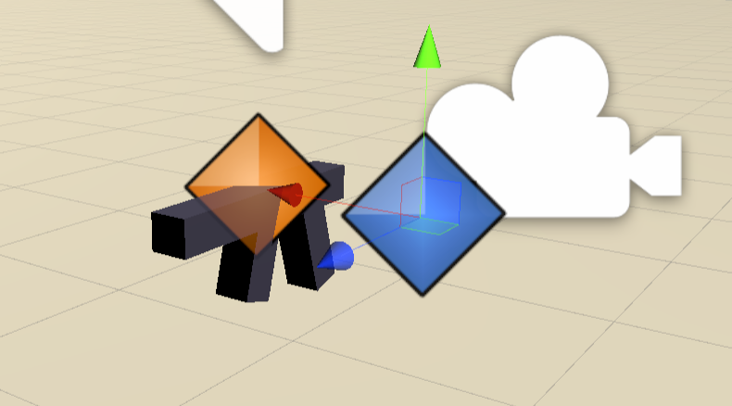

**Step 2**

**Change the rifle script to allow the gun to aim in and out when left clicking.**

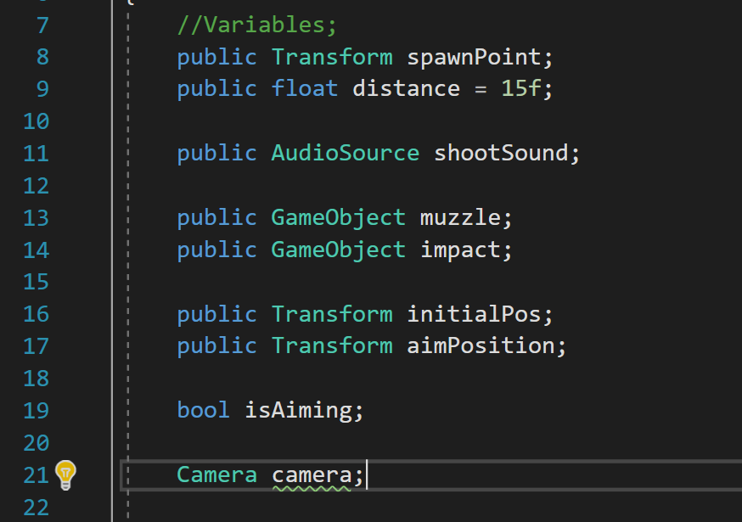

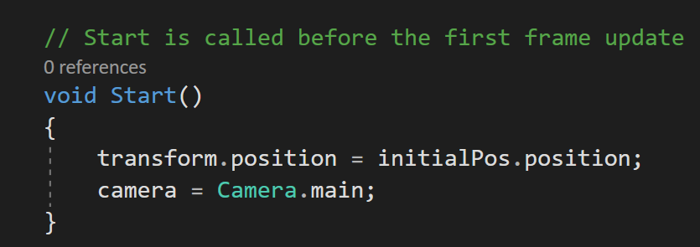

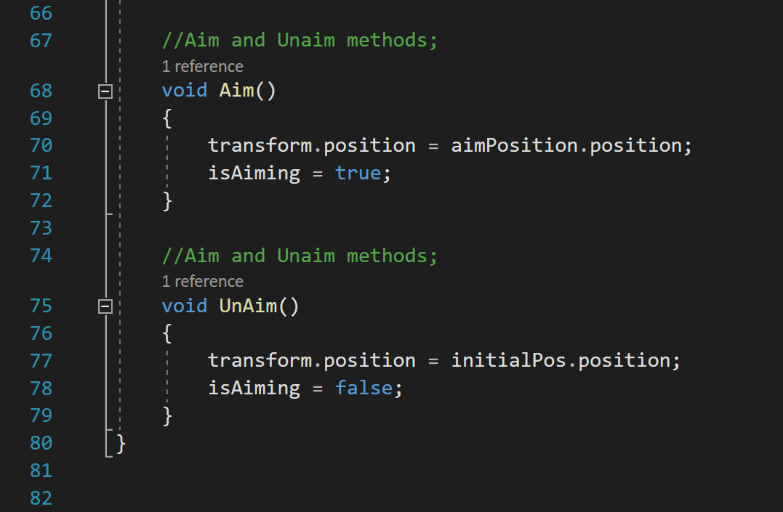

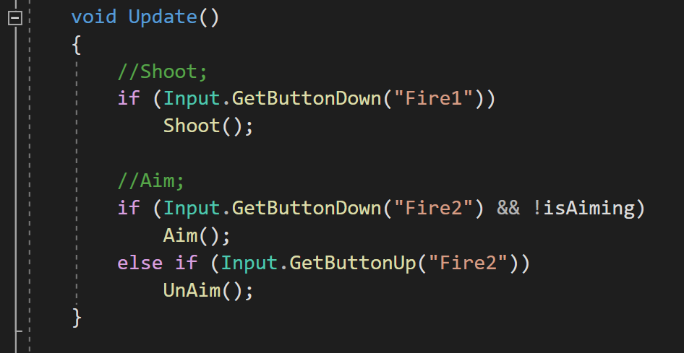

Lastly in the Method to shoot bullets you will need to change SpawnPoint.Position and Spawnpoint.Forward to Camera.transform.

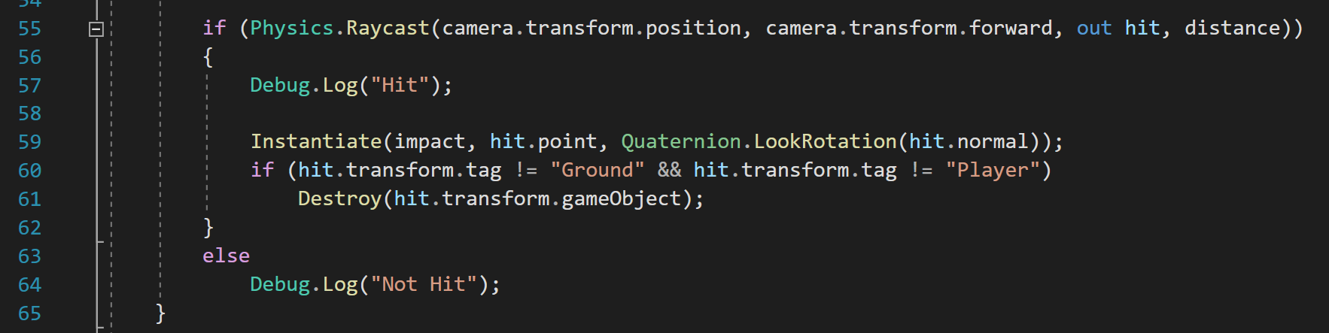

**Step 3**

**Now assign the previous empty object to the script**

To assign the InitiaPosition and Aim position to the rifle you must select the rifle in Hierarchy and in the inspector, you will see two new areas in the rifle script section. You will drag and drop the corresponding names to the inspector

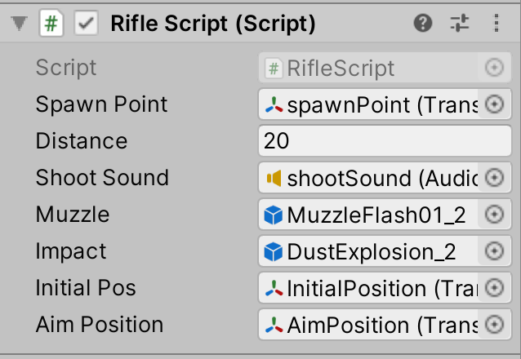

This will now allow you to aim in and out when you play your build.

